**ONLINE ENTERTAINMENT SYSTEM**

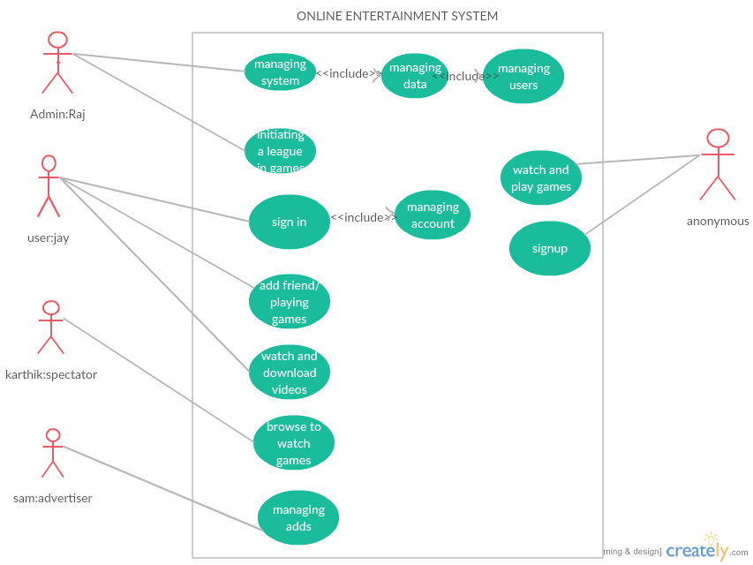

* The above is the UML use case diagram of our online entertainment system which consists of five actors and the roles of actors are explained below

1. **Admin**: admin in our system is raj who can edit the data of users and add or remove games and who is the only one to manage system.(he can add or delete videos and audios).
2. **User**: user in our system is jay who is the registered user of our system who can play games and download the videos or audios in our system.
3. **Spectator**: spectator in our system is karthik who can able to watch the live on going video games.
4. **Advertiser**: Sam is advertiser in our system who can manage adds.
5. **Anonymous**: he or she may be a guest to our system and first time user of our system and who can access to watch the videos and audios and play single player games.(he or she is non registered user of our system).

**USE CASE DIAGRAMS:**

**1)**

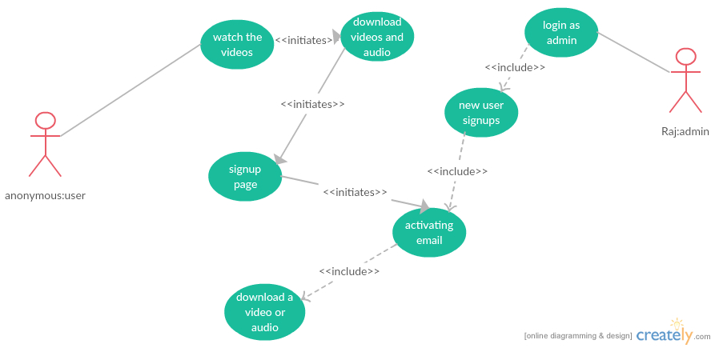

Use case name : Downloading videos.

Participating Actors : initiated by anonymous user

Communicates with the system, admin: Raj.

Flow of Events : 1.Anonymous user visits our website to download some

Videos and he clicks the video button and search for videos

2. He search for a videos and he click the link of the video.

3. He watches some of the videos and he wants to download the video.

4. He clicks the download button which he directed to registering page of the system.

5. He fills the details of his name, Email and other require fields and click submit button.

6. Admin: Raj validates his data and he sends the confirmation mail to the user.

7. User: jay activates his account and he will direct to download page and he will download his video.

Entry condition : anonymous user visits our system.

Exit condition : He downloads his video.

Quality requirements : if user disconnected when download is in progress then user must be able to download his video when he login again.

2)

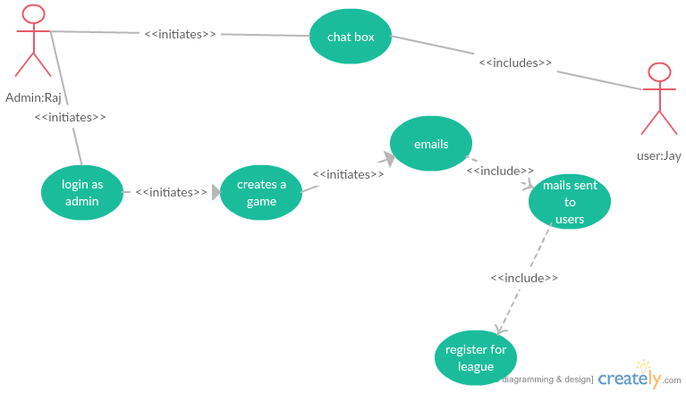

Use case name : creating tournaments.

Participating actors : raj: admin.user: jay.

Flow of events : 1) Raj login to the system as a administrator of the system.

2) As administrator, Raj can create a league in a particular game.(for ex: he creates a world t20 league in cricket game.)

3) After creating a league name with his administrator rights he will send the message to all the users who joined in the system.(about the league duration and rules).

4) After sending the message jay and other users have to register for league (because every league has a limited number of users can play).

5) Raj will create a group with limited number of users and he allows access to users to chat in the chat box.(the chat box will be disabled after the tournament)

Entry condition : raj login to system.

Exit conditions : raj will create a chat box for groups.

3)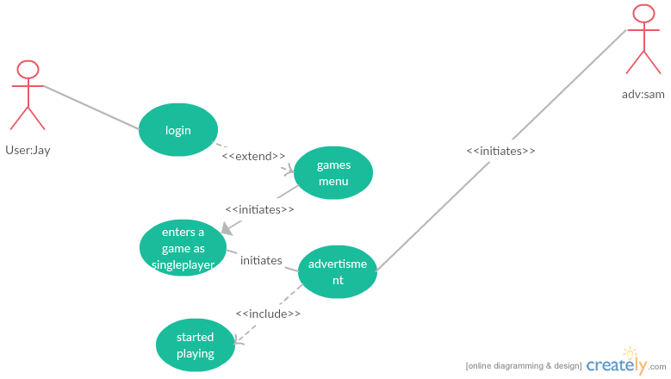

Use case name : playing games

Participating Actors : user: jay, advertiser: Sam

Flow of events : 1) jay logged into the system and he wants to play some

Games.

2) Jay entered into the games menu in the home page and enters into the games window.

3) Jay clicks the particular game (ex: cricket) then advertiser will display a page of ad video for about less than a minute.

4) The advertisers sponsor some redeem points if he wins the game.(like XP points)

5) Jay enters into the game menu and he clicks the single player and he started playing the games.

Entry condition : jay logged into website.

Exit condition : jay started playing a game.

4)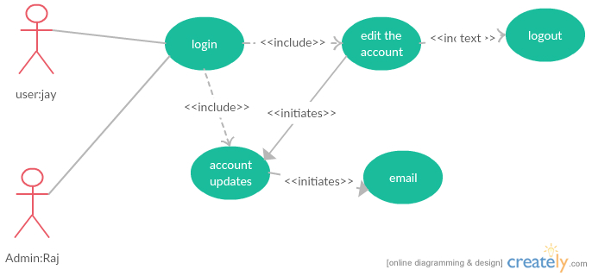

Use case name : editing the data of the user

Participating Actors : user: jay, admin: raj.

Flow of events : 1) jay logged into our website and open his account

2) Jay changes his full name and he changed his password.

3) Jay logged out from the web site.

4) Raj enters the system as an admin.

5) Raj changes the name and the password of the user jay in the database, and he sends the acknowledgement to the jay Email that password has changed.

Entry condition : jay logged into our website.

Exit condition : raj sends acknowledge to jay email.

Quality requirements : if the update of password not satisfies the requirements of password then user should be able to change his password.

5)

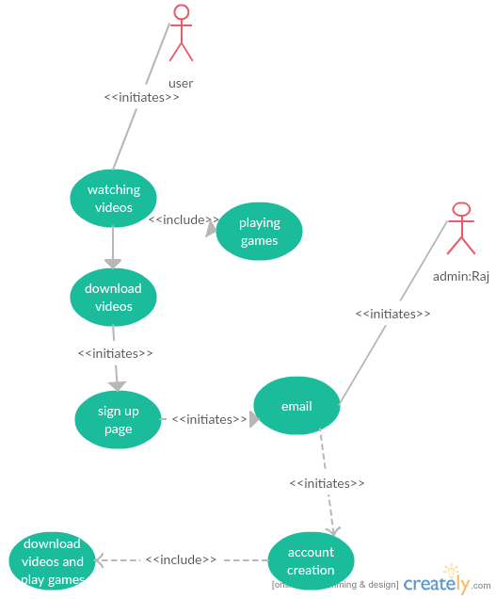.

Use case name : registering for the system.

Participating actors : anonymous user initiates the system

Admin: Raj.

Flow of events : 1) anonymous user enters in to our website.

2) He wants to sign up and click the signup button.

3) Sign up page appears on screen and he or she fills his details and accepts the terms and conditions.

4) After submit the page the user will get message that you can access your account within 15 minutes.

5) The raj gets the new message in sign up page and he accepts the anonymous user request and sends acknowledge to user email.

Entry condition : anonymous user enter into website

Exit condition : Raj sends email to user account.

Quality requirements : if the user was not registered successful he will be acknowledged by the admin.

6)

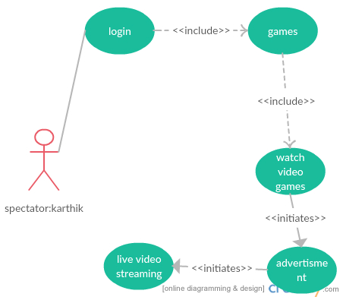

Use case name : watching the video games.

Participating actors : spectator: karthik and interaction of the system.

Flow of events : 1) karthik enter our application home page.

2)Karthik login to our system.

3) He clicks the button games on the home page.

4) He clicks the live video games button on the games page.

5) Our system displays the ongoing video games.

6) Karthik selects a particular video game and our system display certain ad to spectator for less than a second.

7)our system streams the selected video game.

Entry condition : karthik enters to our system.

Exit condition : our system streams the selected video game.

Quality requirement : if karthik disconnected from system after watching ad video he used to be directed to live video game because he already watched the ad.

**SCENARIO:**

Scenario name : Playing a game as multiplayer.

Participating Actors : user: jay, user2:user2.

Flow of events : 1) jay logged into our website and he press the games button in our menu bar.

2) Jay clicks the chess game and he clicks the multiplayer Button.

3) System will display the types of multiplayer types.(like connect to anonymous or friends)

4) Jay clicks the friends and our system displays his friends list that who was online in our system.

5) Jay clicks the user2 button and our system sends the request to user2 and user2 clicks the accept button.

6) Our system connects the both users and opens the chat box. For chatting. And our system is responsible for managing the play.

2)

Scenario name : Listening to songs.

Participating actors : user: jay

Flow of events : 1) jay enters our system and he clicks the songs menu in the menu bar.

2) Our system displays a list of songs by using the country.

3) Jay clicks a particular country name and the system display a certain songs display by particular movie name in alphabetical order.

4) Jay search for his songs in the search bar.

5) Our system displays some songs with search title. And jay clicks certain song.

6) Our system plays a selected song.